**User Guide**

In Online art gallery application, we have three stakeholders’ seller, customers and admin. This user guide provides information to the user for running web application effectively.

**Admin**

Admin can manage customers, sellers and can add or update the categories, Painting details. Also, ordered history and payment record can be viewed from admin portal. The available options are:

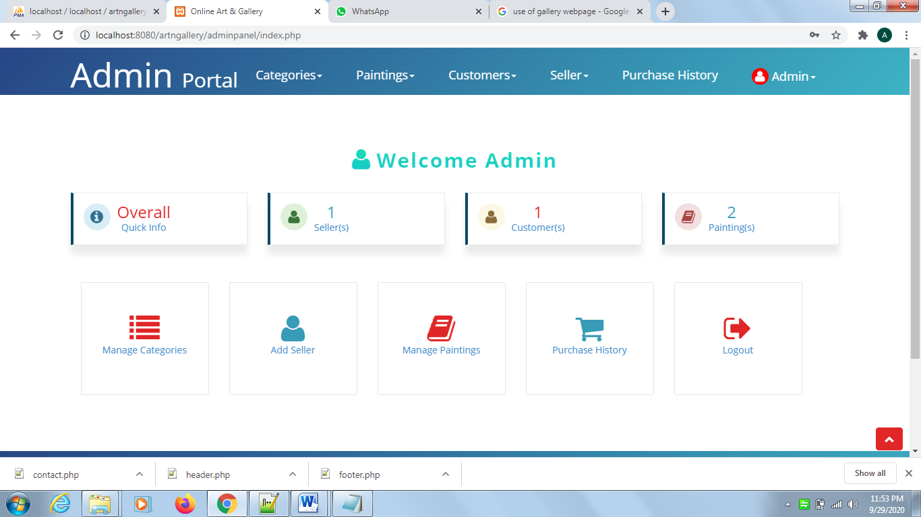

**Seller Portal**

Seller can manage paintings, view ordered paintings and its transaction history. The options for Seller are:

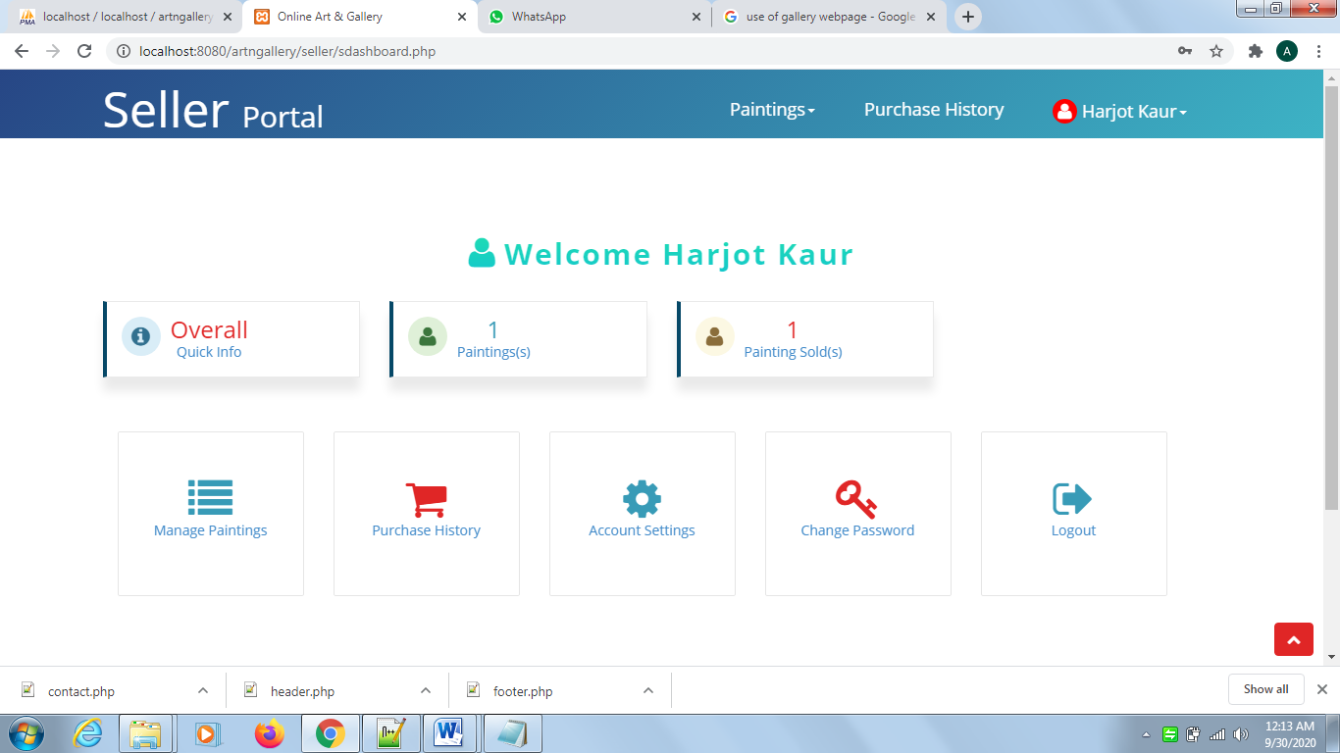

**Customer Portal**

Customer can view the ordered Paintings and transaction history using menu options.

